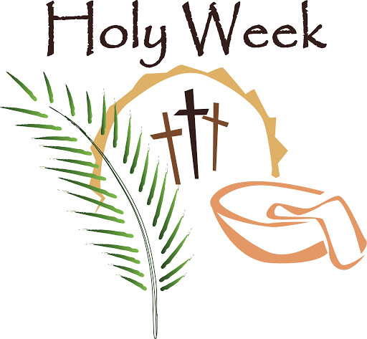

Reflections

Holy Week 2020
Palm Sunday 5 April
Read: Matthew 21; 1-11
Reflection: Who is your favourite celebrity? Who is your favourite football team? When have you or your family achieved a personal best, leading to a celebration? The excitement and anticipation of the crowds must have been amazing to be part of. Yet Jesus entered in humility, on a donkey, as foretold by the prophets.
Prayer: Give thanks for your successes; your celebrations; your joys and ask God to be part of them with you.

Monday 6 April
Reading: John 12: 1-11
Activity; What is your favourite smell? Is it the smell of freshly baked bread? Clean sheets on a washing line? Chanel No 5?
This woman’s act was of kindness, regardless of expense. She was preparing Jesus for what was to come by giving all she had. So often in recent days, we have seen such acts of kindness by random strangers, doing what they can to help those in need. Such beauty and extravagance is evident in our communities.
How can we be extravagant in our worship? How can we prepare for what is to come?
Prayer: Spray some perfume (or air freshener) carefully into the air. As you smell its scent, thank God for all the wonders of the earth and ask how you can be used to keep creation going.

Tuesday 7 April
Reading; John 12: 20-36 Some Greeks wish to see Jesus
Reflection: From Wild Goose big book of resources p77
I wish to see Jesus:
- in the panhandler on Main street – but the unkempt hair, the stained, tattered clothes, the odours fit for a barnyard cloud my eyes.
I wish to hear Jesus:
- in the politicians making decisions I cannot support; in the evangelist mouthing platitudes to the pain-full; in the talk-show callers spewing hateful bile; but their words clog my ears.
I wish to meet Jesus:
- in the tattooed skateboarder riding the rails at the school; in the hip-hopper jamming at the bus stop; in the goths hanging outside the video arcade, but too quickly I cross the street looking for him in folk just like me.
Jesus:
- why would you wish to see; to hear; to meet; me?
Prayer: What would you say if you met Jesus? As you think of your answer, pray that you may find Jesus in the people you meet so that your questions may be answered.

Wednesday 8 April
Reading Hebrews 12: 1-3
Reflection: Get your running shoes on…. The Marathon is due to take place on 26 April – no, wait – it’s moved to 4th October. More time to train, more time to jog and run and be ready to set off on the journey. Life itself is not a sprint – though to watch the world before Covid-19 you would think it was. Now life has changed, is slower, is calmer, is harder. To run any race, we need training, we need support, we need to take action. To live life to the full we need training, we need support, we need to take action. As we pause in the middle of Holy Week, let us reconsider our training schedule to see if it meets the needs of our neighbour.
Prayer: Dear God, may everything I am be a prayer to you. May I race with strength, courage and endurance and fulfil my potential today. Amen (prayer of an athlete from living-prayers.com)

Maundy Thursday 9 April
Reading: 1 Corinthians 11: 23-26 and John 13: 1-7; 31b-35
Activity: As you eat your tea tonight, set aside a piece of bread (or biscuit, or cracker, etc) and a glass of water (or wine or cup of tea). At the end of your meal (either on your own or via the internet with others) pause and reflect on Jesus’ words at the table. When you are ready, break the bread and take a piece for yourself, picturing Jesus and his human life on earth. Give thanks for the life you have and the opportunities available.
Then take your cup and give thanks for all the good things on earth – creation, food, weather etc. Drink your water/wine/tea and remember the divinity of Jesus – the God who made all things good.
Prayer: Pause in silence to reflect on the meal you have just shared and offer thanks to God for Jesus, who gave his all for us that we might be free.

Friday 10 April
Reading: Hebrews 4: 14-16; 5: 7-9 and Psalm 22
Reflection: Who is your “favourite” Jesus on film or tv? Is it “Jesus of Nazareth” with Robert Powell’s piercing blue eyes? It is the horror of “The Passion of the Christ”? What image do you have of Good Friday in your head? The trickle of blood on an otherwise immaculate face or more graphic? Without the horror of Good Friday, there can be no real celebration of the joy of Easter – but let us stay with an image we can bear.
Prayer (from Wild Goose big book of worship resources)
Lord Jesus, lifted high on the cross, you look down on us in all our greatness, and all our sin. And in your amazing love you sift out the good in us, in both our greatness, and our sin.
Look in mercy on all who need you now; especially those who would not dream of approaching you, who feel themselves excluded from your love. Live for them, we pray, as you died for them; and have mercy on us who go in danger of thinking ourselves good, when you have taught us who alone is good, and shown us, by your living and your dying, how we may honour Him. We pray in your name. Amen

Saturday 11 April
Simply pause and reflect.

